

**EXTRAORDINARY**

**TEST**

**UNIVERSIDAD AUTONOMA DE COAHUILA CENTRO DE IDIOMAS US**

LEVEL 10 KIDS

**STUDENT´S NAME: DATE: TEACHER´S NAME: WRITTEN GRADE ORAL GRADE**

End-of-Year Test

Vocabulary

**Vocabulary**

1 Look and write.

ankle boil fireworks mechanic sculpture squirrel suit volcano

|  |  |  |  |
| --- | --- | --- | --- |
|  |  |  |  |
| 1 | 2 | 3 | 4 |
|  |  |  |  |
| 5 | 6 | 7 | 8 |

     / 8

2 Complete the sentences.

a portrait classical music carry-on luggage your wrist

|  |  |
| --- | --- |
|  |  |
| 1                                    is a picture of a person. | 2                                    is between your hand and your arm. |
|  |  |
| 3                                    uses violins, piano, and flutes. | 4                                    is bags you carry on to  a plane. |

     / 4

**Grammar**

3 Look, read, and check .

|  |  |
| --- | --- |
|  | 1 My dad       .  A ☐ is working in the factory tonight  B ☐ will work in the factory tonight |
|  | 2 You have an allergy,       ?  A ☐ didn’t you  B ☐ don't you |
|  | 3 If I didn’t have homework to do,       .  A ☐ I wouldn’t go to the art gallery  B ☐ I would go to the art gallery. |
|  | 4 My brother said       .  A ☐ he had enjoyed the concert last week  B ☐ he enjoys the concert last week |

     / 4

4 Read and circle.

|  |  |
| --- | --- |
|  |  |
| 1 If I **went** / **had gone** to the festival,  I would have tried delicious food. | 2 The mechanic told us she **repairs** / **had repaired** our car and it was ready. |
|  |  |
| 3 Did you know that honey **is made** /  **was made** by bees? | 4 There’s the boy **who** / **what** lives opposite the school. |

     / 4

**Reading**

5 Read and circle T (true) or F (false).

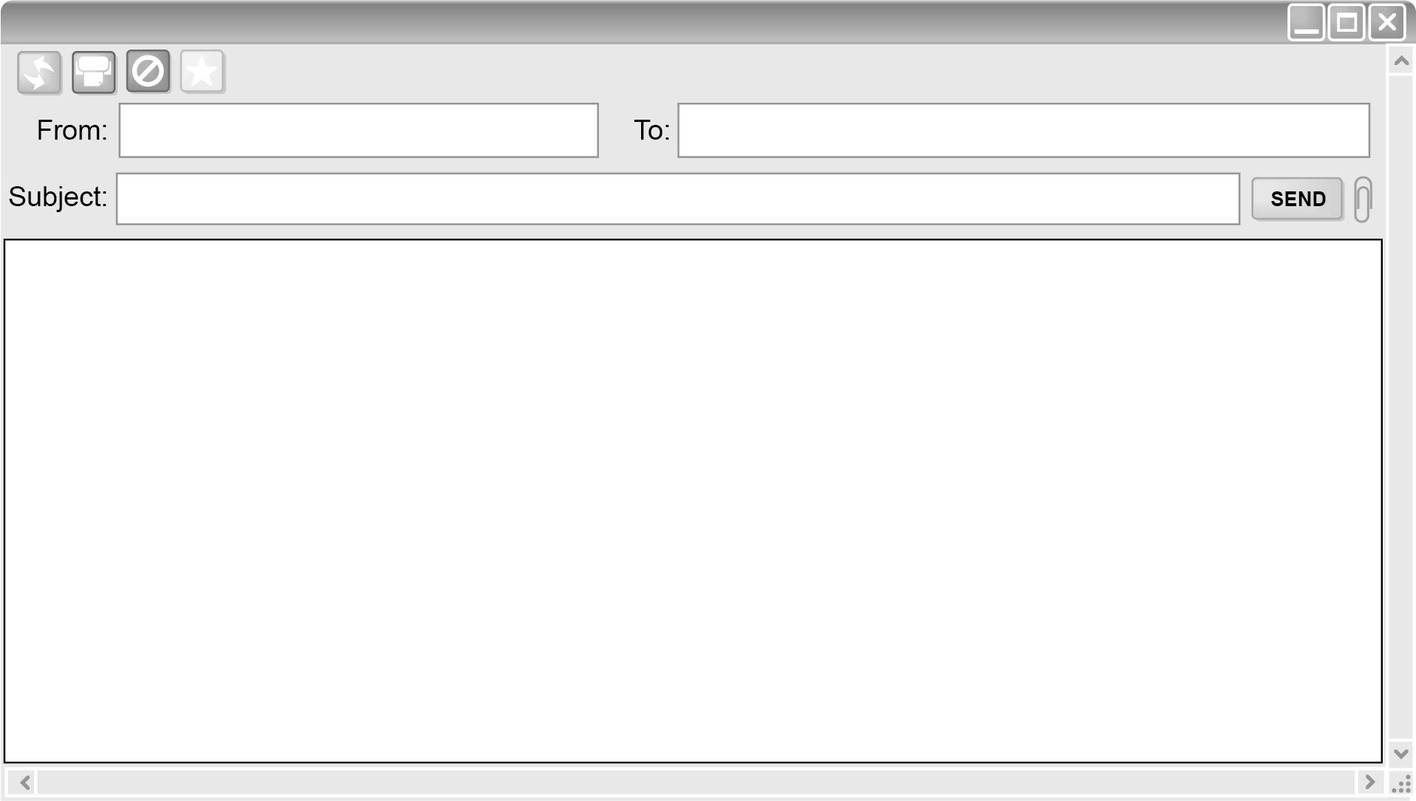

Fergal Dina

Alaska

Hi, Dina,

I’ve just been talking to my big brother. He came back from Alaska yesterday. He stayed with our aunt and uncle, who live there. He said it was amazing! I think we ought to try and go there soon. The best time is in summer when the ice and snow has melted. There are some good airlines that go there. My dad said he would take me next summer. Can you come with me? If I didn’t have tests in September, I would go this year. What do you think? It’s a great idea, isn’t it?

Your friend,

Fergal

1 Fergal’s brother lives in Alaska. T / F

2 Fergal says that he and Dina should go to Alaska. T / F

3 By summer, the snow and ice have gone. T / F

4 They can fly to Alaska. T / F

5 Fergal doesn’t have tests in September. T / F

     / 5

**Writing**

6 Look and write sentences to answer the questions.

|  |  |  |  |  |
| --- | --- | --- | --- | --- |
|  |  |  |  |  |
| 1 | 2 | 3 | 4 | 5 |

1 What do you want to be when you’re older? Why?

2 What are you doing this evening?

3 Would you rather be a performer or a spectator at a carnival? Why?

4 What kind of music do you like? Why?

5 What superpower do you wish you had? Why?

     / 5

**Listening**

14 Listen and number.

|  |  |  |
| --- | --- | --- |
|  |  |  |
| A | B | C |
|  |  |  |
| D | E | F |

     / 6